Year 11 Human Biology - Excretory System Test Mark: /61

Name:________________________ Teacher:______________________________

**PART A: MULTIPLE CHOICE**

1. The removal of metabolic waste products from the body of a mammal is known as
2. Egestion
3. Excretion
4. Secretion
5. Defecation
6. The composition of urea in urine is
   1. 0.5%
   2. 1.5%
   3. 2.0%
   4. 4%
7. Which of the following is **not** a function of the kidneys?
   1. Regulating the composition of the body fluid
   2. Regulating the water balance of the body
   3. Regulating the body temperature
   4. Removing the excess salts
8. Normally, concentrations of metabolically **important** substances are:
   1. High in the glomerular filtrate and low in urine
   2. Low in the glomerular filtrate but high in urine
   3. High in both the glomerular filtrate and urine
   4. Low in both the glomerular filtrate and urine
9. Homeostasis is the mechanism by which the body maintains:
   1. A dynamic physiological state within an unlimited range.
   2. A relatively stable internal environment, within limits.
   3. A static physiological state with no deviation from preset points.
   4. The lowest possible usage of energy.

**PART B: SHORT ANSWER**

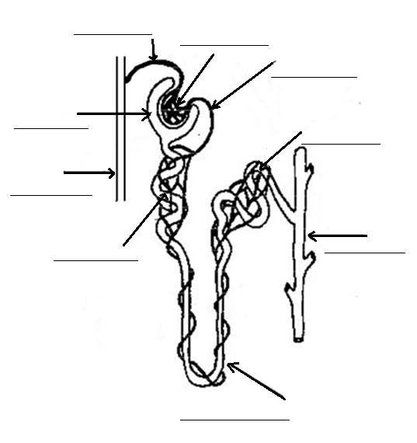1)Label the following diagram of a nephron. (5 marks)

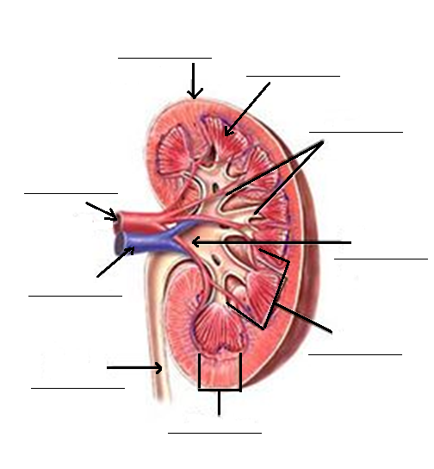2) Label the following diagram of a kidney. (5 marks)

3)Emir decided to go for a run around Lake Monger. He forgot to take his water bottle with him and began feeling a bit light headed and had a bit of a headache.

Complete the feedback loop to explain how Emir’s body is dealing with dehydration. (6 marks)

**Effector**

**Response**

**Stimulus**

**Receptor**

**Feedback**

**Modulator**

4) Complete the table below. Not all the boxes should be filled. (10 marks)

|  |  |  |  |
| --- | --- | --- | --- |
| Part of nephron | Substances being  reabsorbed | Substances being  filtered | Substances being  secreted |
| Loop of Henle |  |  |  |
| Collecting duct | Water |  |  |
| Bowman’s capsule |  | Glucose  Phosphate ions |  |
| Distal convoluted  tubule |  |  |  |
| Proximal convoluted  tubule | Sodium ions  Glucose |  |  |

5) Why can some substances pass through the membrane of the glomerulus, but others cannot?

Give 2 examples of substances that can pass through, and 2 substances that cannot. (5 marks)

__________________________________________________________________________________________

__________________________________________________________________________________________

__________________________________________________________________________________________

__________________________________________________________________________________________

__________________________________________________________________________________________

__________________________________________________________________________________________

__________________________________________________________________________________________

6a) Explain how blood in the glomerulus kept under a high pressure. (3 marks)

__________________________________________________________________________________________

__________________________________________________________________________________________

__________________________________________________________________________________________

__________________________________________________________________________________________

__________________________________________________________________________________________

__________________________________________________________________________________________

__________________________________________________________________________________________

b) Why is it so important that this blood be kept under a high pressure? (2 marks)

__________________________________________________________________________________________

__________________________________________________________________________________________

__________________________________________________________________________________________

__________________________________________________________________________________________

__________________________________________________________________________________________

**PART C: EXTENDED ANSWER**

7)Raylene drank four cups of coffee, explain down **in detail** the effect this will have on the reabsorption of water in her body. You must include step by step details.

__________________________________________________________________________________________

__________________________________________________________________________________________

__________________________________________________________________________________________

__________________________________________________________________________________________

__________________________________________________________________________________________

__________________________________________________________________________________________

__________________________________________________________________________________________

__________________________________________________________________________________________

__________________________________________________________________________________________

__________________________________________________________________________________________

__________________________________________________________________________________________

__________________________________________________________________________________________

__________________________________________________________________________________________

__________________________________________________________________________________________

__________________________________________________________________________________________

__________________________________________________________________________________________

__________________________________________________________________________________________

__________________________________________________________________________________________

__________________________________________________________________________________________

__________________________________________________________________________________________

__________________________________________________________________________________________

__________________________________________________________________________________________

__________________________________________________________________________________________

(10 marks)

8)Describe the process of protein deamination in the human body.

You must include step by step details.

__________________________________________________________________________________________

__________________________________________________________________________________________

__________________________________________________________________________________________

__________________________________________________________________________________________

__________________________________________________________________________________________

__________________________________________________________________________________________

__________________________________________________________________________________________

__________________________________________________________________________________________

__________________________________________________________________________________________

__________________________________________________________________________________________

__________________________________________________________________________________________

__________________________________________________________________________________________

__________________________________________________________________________________________

__________________________________________________________________________________________

__________________________________________________________________________________________

__________________________________________________________________________________________

__________________________________________________________________________________________

__________________________________________________________________________________________

__________________________________________________________________________________________

__________________________________________________________________________________________

__________________________________________________________________________________________

__________________________________________________________________________________________

__________________________________________________________________________________________

(10 marks)